**Set up**

This is an instruction to guarantee the project can be run under your computer’s environment successfully, the instruction is going to take FullSourceCode as an example.

Firstly, for connecting to the database we used, which is provided by University of Kent, you need to make sure your computer is with the university Wi-Fi or you can use the school vpn instead. Go to the source code folder, in this case is FllSourceCode and run command node server (*Note: You would need to install NodeJs and npm if you don’t have one) e.g. fig. 1.

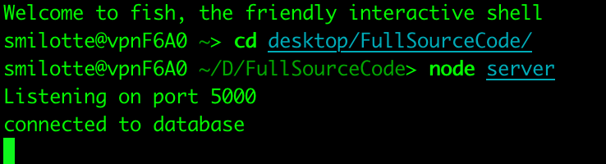

Fig. 1 Connecting to Database

You are now successfully connecting to the database. Then you would need to start the react app with npm which is a tool with node.js. Go to the client folder which is under the source folder. For the first time starting, you would need to reboot the project with the following commands: chmod +x node_modules/.bin/react-scripts. And then with npm start command, the project could start sucessfully Fig. 2.

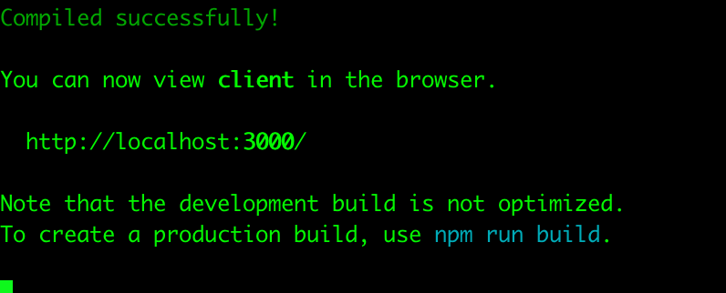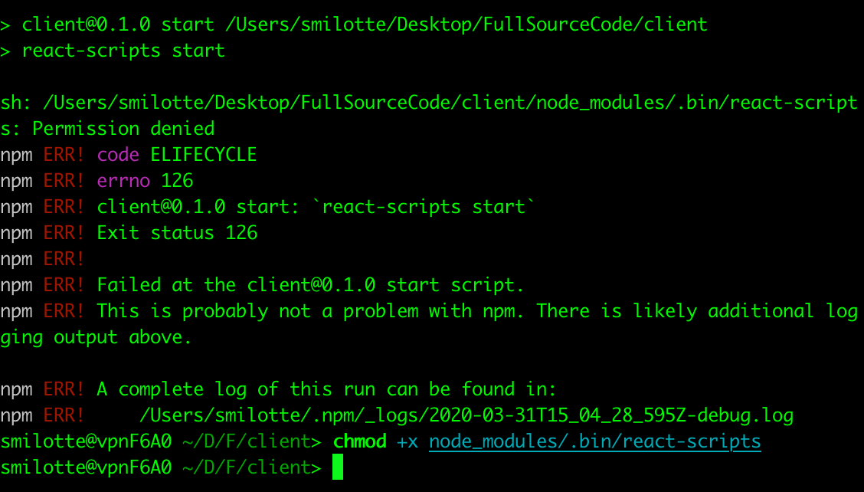

Fig. 2 Reboot and start with npm start